*Heaven’s light is our guide.*

*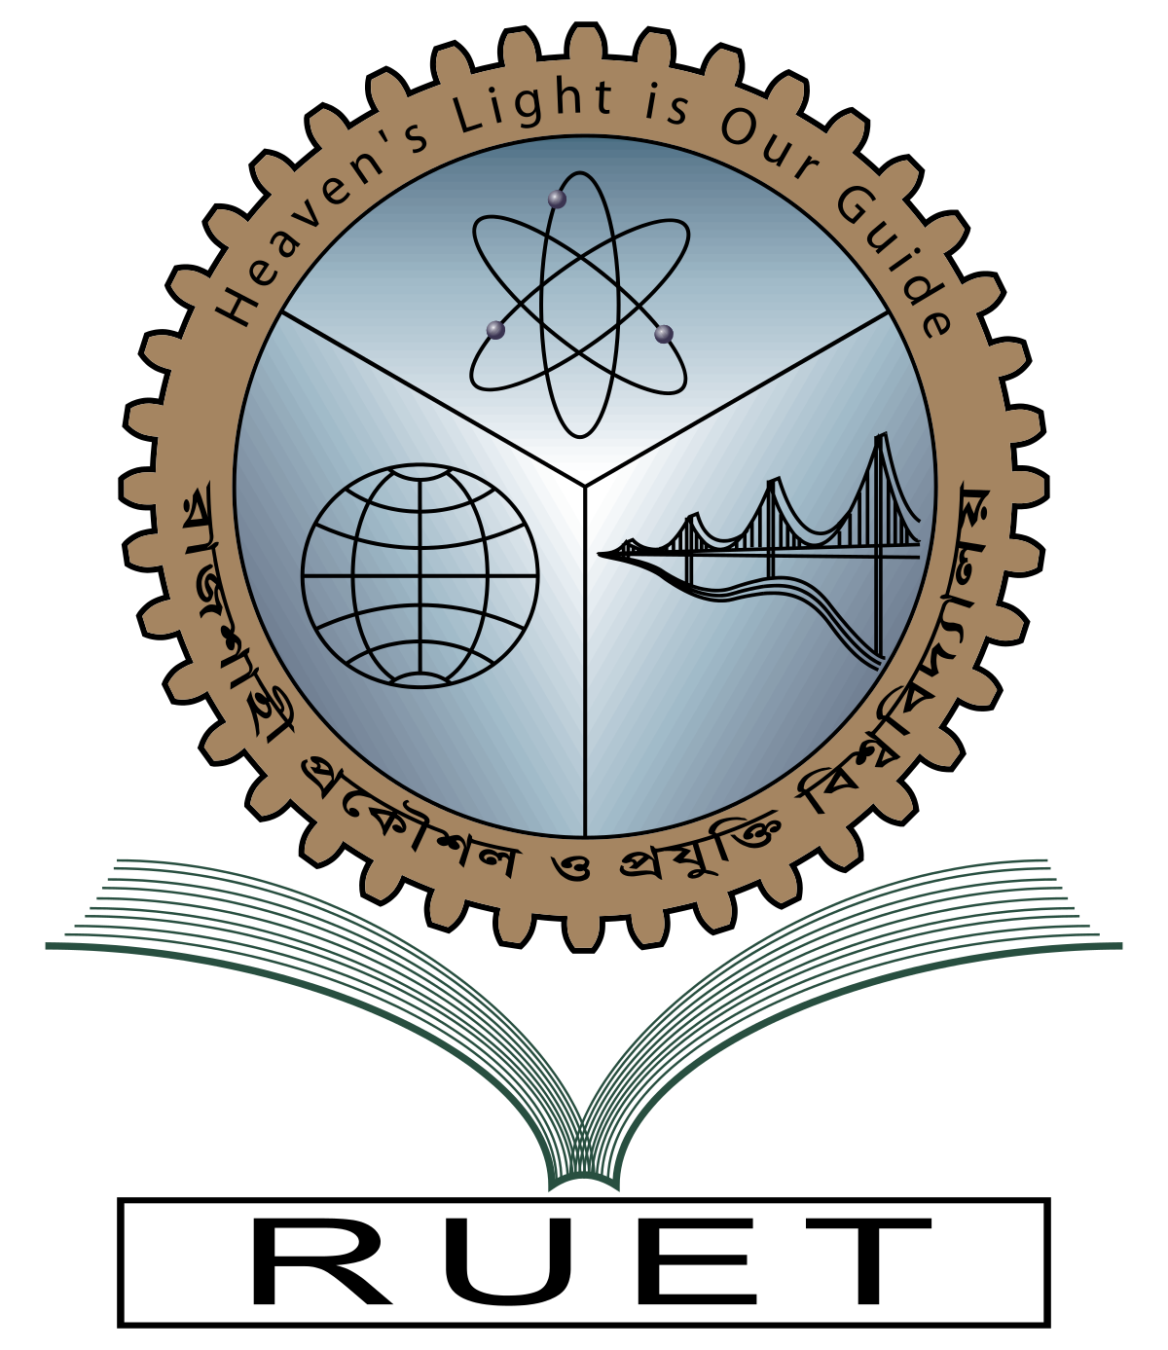***Rajshahi University of Engineering and Technology**

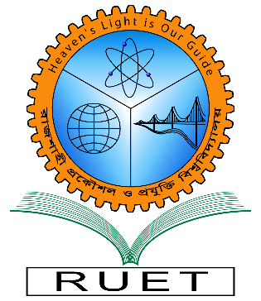

**Department of Electrical & Electronic Engineering**

**Course no.** EEE3200

**Course title:** Electrical & Electronic Circuit Simulation Sessional

**Experiment no.** 11

**Experiment name:** Simulation on three-phase (abc) to two-phase (αβ0) transformation system

**Date of experiment:** January 11, 2022

**Date of submission:** January 17, 2022

|  |  |
| --- | --- |
| **Submitted to:** | **Submitted by:** |
| **Md. Razon Chowdhury**  **Assistant Professor**  Dept. of Electrical & Electronic Engineering,  Rajshahi University of Engineering and Technology. | **Ashraf Al- Khalique**  **Roll:** 1801171  **Session:** 2018-2019  Dept. of Electrical & Electronic Engineering,  Rajshahi University of Engineering and Technology. |